**BID MANAGEMENT 2.0**

01 Object : Bid Registration

01 VF : Customer Bid Registration

01 Section & Fields

a) Customer Info ---- Type , name, Contact Details, Company Details

b) Bid Details ---- Source, Published on , Requirement

c) competitor Details -- 2 Mojor Competitors name, city, Pricing points

d) Product Details --- OrderNo, Date, Part No. Qty , Price, New Price, Qty Requested Special Comments

e) Save, Submit , Cancel, Delete(Approved & Submited cannot be deleted)

f) formulas and validations --- Discount Calc, Total Discount

02. As soon as Submit button is clicked system should create another record in another table

02. Object : Bid Request

02 Section & Fields

a) Customer Info ---- Type , name, Contact Details, Company Details

b) Bid Details ---- Source, Published on , Requirement

c) competitor Details -- 2 Mojor Competitors name, city, Pricing points

d) Product Details --- OrderNo, Date, Part No. Qty , Price, New Price, Qty Requested Special Comments

e) Internal Details --- Before Margin, After Margin, Product manafactring cost.

f) Qtr Budject and Costing --- Budget allocoated , Utilization, Budjet Remaning, Budget Exiry

02. Approval Matrix : 2 Tier (based on Margin - 10> Auto Approved , 5-10- Level 1, 0-5 Level 2 , Negative - aUTO Reject.

03. VF page - Rerender as PDF / Email Template

----------------------------------------------------------------------------

04. Claim Request Form

04. Section& Fields

a) Approval Details - Approval Id, Approval Date , Qty Approve , uNIT dISCOUNT , tOTAL Discount.

b) Claim Deatils - End Cust, Sold on, Sold Qty , Selling Price, Invoice No. Status, Claim Qty,Claim Discount, Claim Date, Calim Submitedby .

05. As soon as Submit button is clicked system should create another record in another table

06.Claims ---Approved by, Before Margin, After Margin, Product manafactring cost.Approval Button

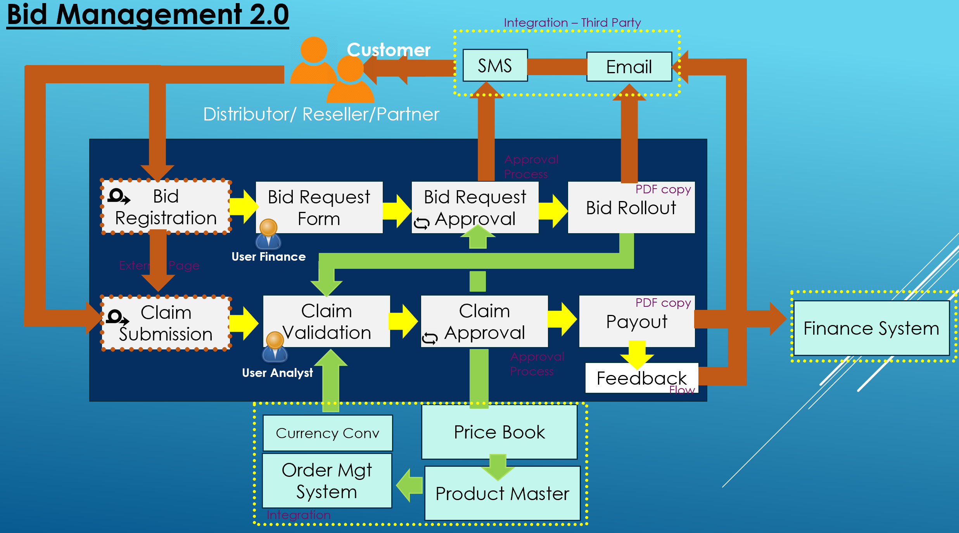

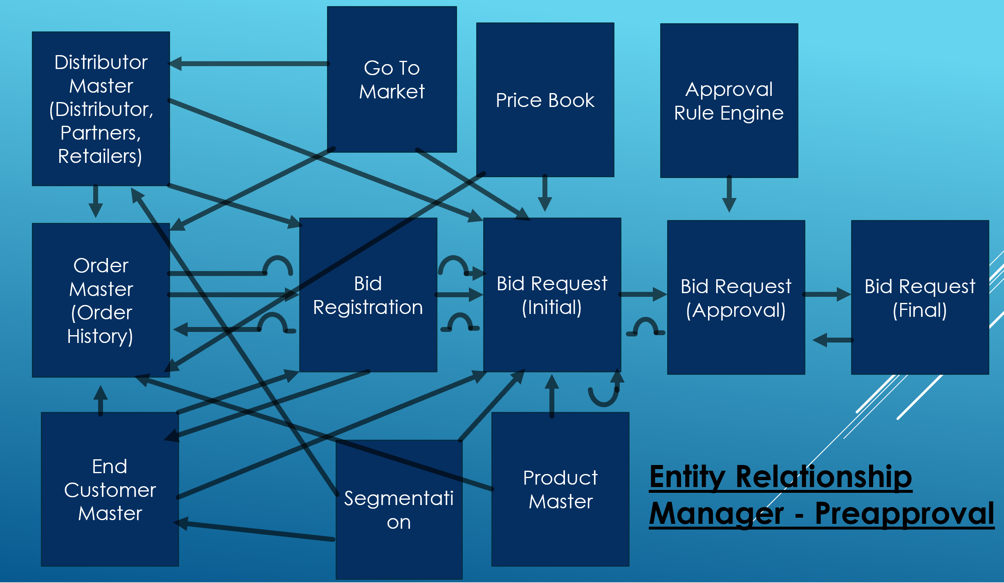

***Home Page:***

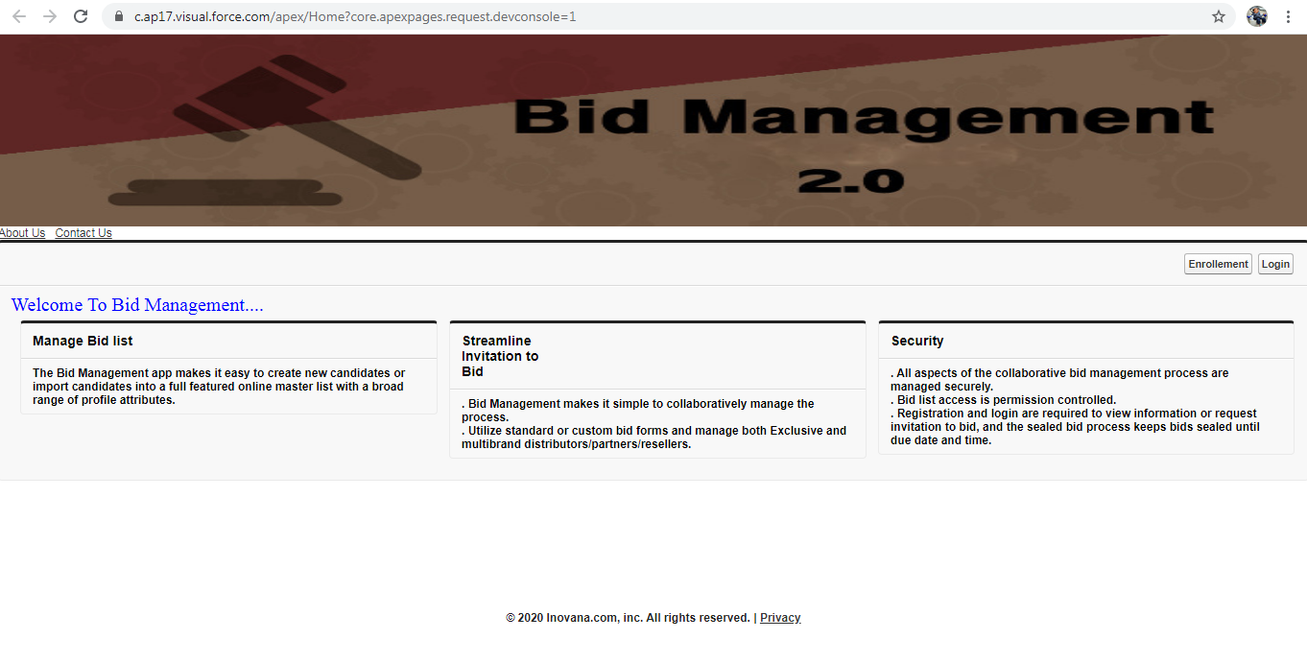

*Apex Class:*

public class C_Bid_Home   
{  
  Public PageReference Enrollement()  
    {  
        String Enrollurl = '/apex/Dealer_List';  
        PageReference PR= New PageReference(Enrollurl);  
        Return PR;  
    }  
    Public PageReference Login()  
    {  
        String Loginurl = '/apex/LoginPage';  
          
        PageReference PR = New PageReference(Loginurl);  
        return PR;  
    }  
}

*VF Page:*

<apex:page controller="C_Bid_Home">

<style>

.h1

{

overflow:scroll;

}

.sidebar

{

Height:100px;

width:30px;

border:ridge ;

}

.text

{

font-family: "Times New Roman", Times, serif;

font-size: 20px;

color:blue;

}

</style>

<apex:image value="{!$Resource.Hm4}" height="200" width="1366"/><br/>

<apex:outputLink value="{!'/apex/SiteInformation_AboutUs'}">About Us</apex:outputLink>&nbsp;&nbsp;&nbsp;

<apex:outputLink value="{!'/apex/SiteInformation_ContactUs'}">Contact Us</apex:outputLink>

<apex:pageBlock >

<apex:pageBlockButtons id="pbb1" dir="RTL" location="Top">

<apex:form ><apex:commandButton id="cb1" value="Login" action="{!Login}"/>

<apex:commandButton id="cb2" value="Enrollement" action="{!Enrollement}" /></apex:form>

</apex:pageBlockButtons>

<apex:outputText styleClass="text" value="Welcome To Bid Management...."/>

<apex:pageBlockSection columns="3">

<apex:pageBlock title="Manage Bid list">

<b>The Bid Management app makes it easy to create new candidates or import candidates into a full featured online master list with a broad range of profile attributes.</b>

</apex:pageBlock>

<apex:pageBlock title="Streamline Invitation to Bid">

<b>. Bid Management makes it simple to collaboratively manage the process.<br/>

. Utilize standard or custom bid forms and manage both Exclusive and multibrand distributors/partners/resellers.</b>

</apex:pageBlock>

<apex:pageBlock title="Security">

<b> . All aspects of the collaborative bid management process are managed securely.<br/>

. Bid list access is permission controlled.<br/>

. Registration and login are required to view information or request invitation to bid, and the sealed bid process keeps bids sealed until due date and time.</b>

</apex:pageBlock>

</apex:pageBlockSection>

</apex:pageBlock><br/><br/><br/><br/><br/><br/><br/><br/><br/>

<center><b> © 2020 Inovana.com, inc. All rights reserved.&nbsp;|&nbsp;

<apex:outputLink value="https://Invovana.com/">Privacy</apex:outputLink></b></center>

</apex:page>

*AboutUs Page:*



*ContactUs Page:*



*Enrollment Page:*

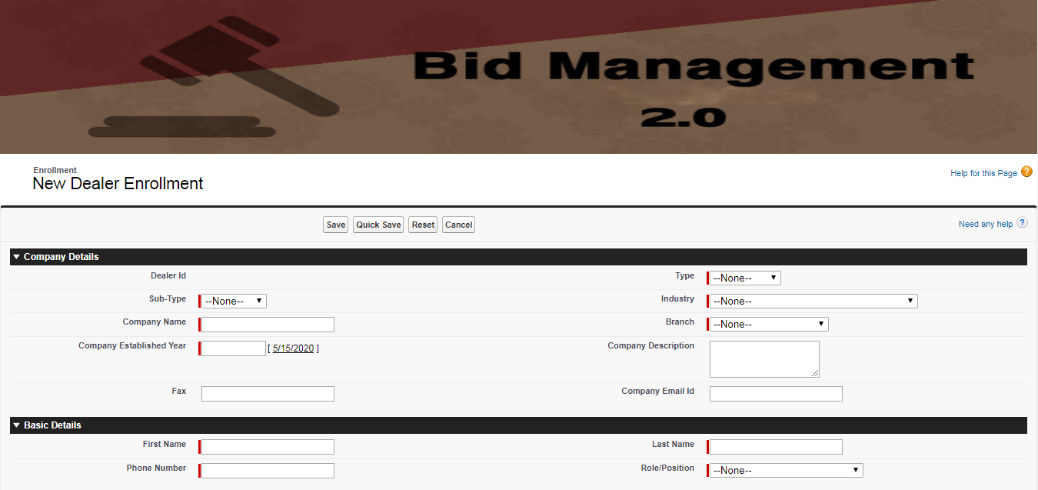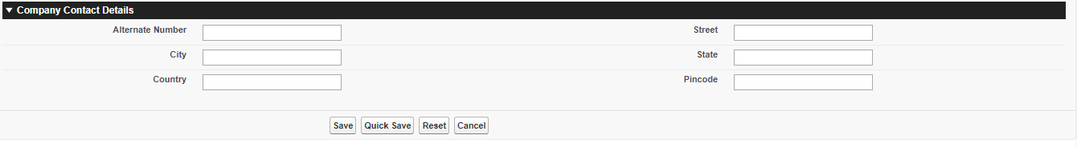

*Apex Class:*

public class C_Bid_DealerPage  
{  
    Public Dealer_List__c Dlr {set; get;}  
    Public C_Bid_DealerPage()  
  {  
      Dlr = new Dealer_List__c();  
  }  
      
    public void CreateDealer()  
    {  
        try  
        {  
            insert Dlr;  
            ApexPages.Message M = New ApexPages.Message(ApexPages.Severity.CONFIRM, 'Enrollment done successfully');  
            ApexPages.addMessage(M);  
        }  
        catch(exception e)  
        {  
            ApexPages.Message M1= new apexPages.Message(ApexPages.Severity.ERROR, 'Enrollment Failed with an Exception: '+e);  
            ApexPages.addMessage(M1);  
        }  
    }  
}

*VF Page:*

<apex:page id="p1" controller="C_Bid_DealerPage">

<apex:image id="img1" value="{!$Resource.Hm4}" height="200" width="1366"/><br/>

<apex:sectionHeader id="sh1" title="Enrollment" subtitle="New Dealer Enrollment" help="/apex/Home"/>

<apex:form id="f1">

<apex:pageBlock id="pb1" helpTitle="Need any help" helpUrl="/apex/Home">

<apex:pageBlockButtons id="pbb1" location="both">

<apex:commandButton id="cb1" value="Save" action="{!CreateDealer}" />

<apex:commandButton id="cb2" value="Quick Save" action="{!CreateDealer}" />

<apex:commandButton id="cb3" value="Reset" reRender="f1"/>

<apex:commandButton id="cb4" value="Cancel" />

</apex:pageBlockButtons>

<apex:pageBlockSection id="pbs1" title="Company Details">

<apex:pageBlockSectionItem id="pbsi1" >

<apex:outputLabel id="ol1" value="Dealer Id"/>

<apex:inputField id="it1" value="{!Dlr.Name}" />

</apex:pageBlockSectionItem>

<apex:pageBlockSectionItem id="pbsi2" >

<apex:outputLabel id="ol1" value="Type"/>

<apex:inputField id="it1" value="{!Dlr.Type__c}" />

</apex:pageBlockSectionItem>

<apex:pageBlockSectionItem id="pbsi3" >

<apex:outputLabel id="ol1" value="Sub-Type"/>

<apex:inputField id="it1" value="{!Dlr.Sub_Type__c}" />

</apex:pageBlockSectionItem>

<apex:pageBlockSectionItem id="pbsi4" >

<apex:outputLabel id="ol1" value="Industry"/>

<apex:inputField id="it1" value="{!Dlr.Industry__c}" />

</apex:pageBlockSectionItem>

<apex:pageBlockSectionItem id="pbsi5" >

<apex:outputLabel id="ol1" value="Company Name"/>

<apex:inputField id="it1" value="{!Dlr.Company_Name__c}" />

</apex:pageBlockSectionItem>

<apex:pageBlockSectionItem id="pbsi6" >

<apex:outputLabel id="ol1" value="Branch"/>

<apex:inputField id="it1" value="{!Dlr.Branch__c}" />

</apex:pageBlockSectionItem>

<apex:pageBlockSectionItem id="pbsi7" >

<apex:outputLabel id="ol1" value="Company Established Year"/>

<apex:inputField id="it1" value="{!Dlr.Company_Established_Year__c}" />

</apex:pageBlockSectionItem>

<apex:pageBlockSectionItem id="pbsi8" >

<apex:outputLabel id="ol1" value="Company Description"/>

<apex:inputField id="it1" value="{!Dlr.Company_Description__c}" />

</apex:pageBlockSectionItem>

<apex:pageBlockSectionItem id="pbsi9" >

<apex:outputLabel id="ol1" value="Fax"/>

<apex:inputField id="it1" value="{!Dlr.Fax__c}" />

</apex:pageBlockSectionItem>

<apex:pageBlockSectionItem id="pbsi10" >

<apex:outputLabel id="ol1" value="Company Email Id"/>

<apex:inputField id="it1" value="{!Dlr.Company_Email_Id__c}" />

</apex:pageBlockSectionItem>

</apex:pageBlockSection>

<apex:pageBlockSection id="pbs2" title="Basic Details">

<apex:pageBlockSectionItem id="pbsi1" >

<apex:outputLabel id="ol1" value="First Name"/>

<apex:inputField id="it1" value="{!Dlr.First_Name__c}" />

</apex:pageBlockSectionItem>

<apex:pageBlockSectionItem id="pbsi2" >

<apex:outputLabel id="ol1" value="Last Name"/>

<apex:inputField id="it1" value="{!Dlr.Last_Name__c}" />

</apex:pageBlockSectionItem>

<apex:pageBlockSectionItem id="pbsi3" >

<apex:outputLabel id="ol1" value="Phone Number"/>

<apex:inputField id="it1" value="{!Dlr.Phone_Number__c}" />

</apex:pageBlockSectionItem>

<apex:pageBlockSectionItem id="pbsi4" >

<apex:outputLabel id="ol1" value="Role/Position"/>

<apex:inputField id="it1" value="{!Dlr.Role_Position__c}" />

</apex:pageBlockSectionItem>

</apex:pageBlockSection>

<apex:pageBlockSection id="pbs3" title="Company Contact Details">

<apex:pageBlockSectionItem id="pbsi1" >

<apex:outputLabel id="ol1" value="Alternate Number"/>

<apex:inputField id="it1" value="{!Dlr.Alternate_Number__c}" />

</apex:pageBlockSectionItem>

<apex:pageBlockSectionItem id="pbsi2" >

<apex:outputLabel id="ol1" value="Street"/>

<apex:inputField id="it1" value="{!Dlr.Street__c}" />

</apex:pageBlockSectionItem>

<apex:pageBlockSectionItem id="pbsi3" >

<apex:outputLabel id="ol1" value="City"/>

<apex:inputField id="it1" value="{!Dlr.City__c}" />

</apex:pageBlockSectionItem>

<apex:pageBlockSectionItem id="pbsi4" >

<apex:outputLabel id="ol1" value="State"/>

<apex:inputField id="it1" value="{!Dlr.State_Province_Region__c}" />

</apex:pageBlockSectionItem>

<apex:pageBlockSectionItem id="pbsi5" >

<apex:outputLabel id="ol1" value="Country"/>

<apex:inputField id="it1" value="{!Dlr.Country__c}" />

</apex:pageBlockSectionItem>

<apex:pageBlockSectionItem id="pbsi6" >

<apex:outputLabel id="ol1" value="Pincode"/>

<apex:inputField id="it1" value="{!Dlr.Pincode__c}" />

</apex:pageBlockSectionItem>

</apex:pageBlockSection>

</apex:pageBlock>

</apex:form>

</apex:page>

***Login Page:***



***Forgot Password Page:***



***Reset Password:***

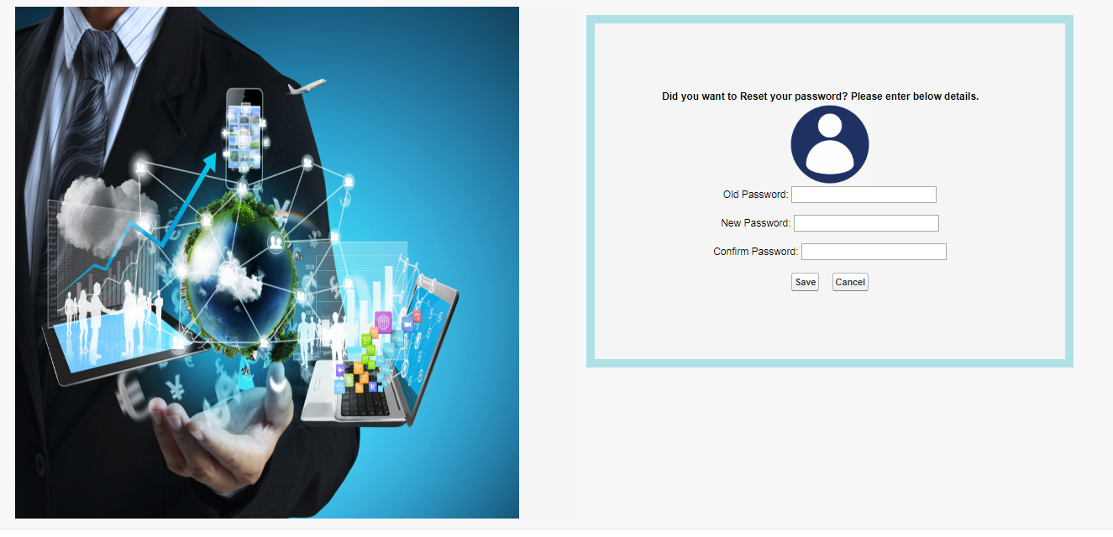

|  |  |  |  |  |
| --- | --- | --- | --- | --- |
| S.No | Field Name | Data Type | Value | Validation |
| 1 | Registration Id | Auto Num | REGID-{000001}-mmyyyy | - |
| 2 | Last Name | Text,Required | 100 | - |
| 3 | First Name | Text,Required | 100 | - |
| 4 | Name Of the Distributor | Formula | LN- FN |  |
| 5 | Email Id | Email,Required | a@a.com | - |
| 6 | Fax | Text | 80 | - |
| 7 | Phone Number | Phone,Required | 9985464537 | Valid no. & should contain 10 digits |
| 8 | Alternate Number | Phone | 6754389654 | - |
| 9 | Street | text | abcd | - |
| 10 | City | text | abcddde | - |
| 11 | State | text |  |  |
| 12 | Country | text |  |  |
| 13 | Pincode | text |  |  |
| 14 | Location | Geolacation | Latitude  Longitute |  |
| Product Details | | | | |
| 15 | Re-Bid Submission | Checkbox, required |  |  |
| 16 | Revise Discount | Currency, Required | $10 |  |
| 17 | Description | TextArea | -Some text- |  |
| 18 | Payment Mode | Picklist,required |  |  |
| 19 | Account Id | Number,required | 12345678909 |  |
| 20 | Bid Submission Date | Date,required | 4/3/2020 |  |
| Order Details | | | | |
| 21 | Order List | Lookup(Order_List__c) | OrderID-000001-mmyyyy |  |
| 22 | Cmp Name of the Distributor | formula |  |  |
| 23 | Type | formula | Value from Picklist |  |
| 24 | Sub-Type | formula | Value from Picklist |  |
| 25 | Product Quantity Ordered | formula |  |  |
| 26 | Ordered Discount | formula |  |  |
| 27 | Actual Price | formula |  |  |
| 28 | Total Revenue | formula |  |  |
| 29 | Shipping Date | formula |  |  |
| 30 | Ordered Closed Date | formula |  |  |
| End Customer Details | | | | |
| 31 | End Customer List | lookup(End_Customer_List) | Bid-ECustID-{000001}-mmyyyy |  |
| 32 | CompanyName | formula |  |  |
| 33 | Company Email | formula |  |  |
| 34 | Company Phone | phone | 5647654328 |  |
| 35 | Account Type Head | formula |  |  |
| 36 | Other Phone Number | Formula |  |  |
| 37 | Company Location | Formula |  |  |
| 38 | Source | Formula |  |  |
| 39 | Quantity Ordered | Formula |  |  |
| 40 | Published Date | Formula |  |  |
| 41 | Street | Formula |  |  |
| 42 | City | Formula |  |  |
| 43 | State | Formula |  |  |
| 44 | Country | Formula |  |  |
| 45 | Pincode | Formula |  |  |
| 46 | Start Date | Formula |  |  |
| 47 | End Date | Formula |  |  |

***VF Page:[Bid Registration]***

<apex:page id="p1" standardController="Bid_Registration__c" showHeader="false" sidebar="false">

<apex:image value="{!$Resource.Hm4}" height="200" width="1366"/><br/>

<apex:sectionHeader id="sh1" title="Bid Registration" subtitle="New Bid Registration" help="/apex/Home"/>

<apex:form id="f1">

<apex:pageBlock tabStyle="Order_List__c" id="pb1" title="Bid Registration Form" helpTitle="Need any help??" helpUrl="https://developer.salesforce.com/docs/atlas.en-us.pages.meta/pages/pages_compref_pageBlockSection.htm">

<apex:pageBlockButtons id="pbb1" location="both">

<apex:commandButton id="cb1" value="Save" />

<apex:commandButton id="cb2" value="Save&New" />

<apex:commandButton id="cb3" value="Edit" />

<apex:commandButton id="cb4" value="Delete" />

<apex:commandButton id="cb5" value="Reset" />

<apex:commandButton id="cb6" value="Cancel" />

</apex:pageBlockButtons>

<apex:pageBlockSection id="pbs1" title="Basic Details" >

<apex:inputField id="if1" value="{!Bid_Registration__c.Name}" />

<apex:inputField id="if2" value="{!Bid_Registration__c.Name_Of_the_Distributor__c}" />

<apex:inputField id="if3" value="{!Bid_Registration__c.Email_Id__c}" />

<apex:inputField id="if4" value="{!Bid_Registration__c.Fax__c}" />

<apex:inputField id="if5" value="{!Bid_Registration__c.Phone_Number__c}" />

<apex:inputField id="if6" value="{!Bid_Registration__c.Alternate_Number__c }" />

<apex:inputField id="if7" value="{!Bid_Registration__c.Street__c}" />

<apex:inputField id="if8" value="{!Bid_Registration__c.City__c}" />

<apex:inputField id="if9" value="{!Bid_Registration__c.State_Province_Region__c}" />

<apex:inputField id="if10" value="{!Bid_Registration__c.Country__c}" />

<apex:inputField id="if11" value="{!Bid_Registration__c.Pincode__c}" />

<!--<apex:inputField value="{!Bid_Registration__c.Latitude__c}" />

<apex:inputField value="{!Bid_Registration__c.Longitude__c}" />-->

</apex:pageBlockSection>

<apex:pageBlockSection id="pbs2" title="Bid Details">

<apex:inputField id="if2" value="{!Bid_Registration__c.Revise_Discount__c}" />

<apex:inputField id="if4" value="{!Bid_Registration__c.Payment_Mode__c}" />

<apex:inputField id="if5" value="{!Bid_Registration__c.Re_Bid_Submission__c}" />

<apex:inputField id="if6" value="{!Bid_Registration__c.Bid_submission_Date__c }" />

<apex:inputField id="if7" value="{!Bid_Registration__c.Account_Id__c }" />

<apex:inputField id="if8" value="{!Bid_Registration__c.Description__c}" />

</apex:pageBlockSection>

<apex:pageBlockSection id="pbs3" title="Order Details">

<apex:inputField id="if1" value="{!Bid_Registration__c.Order_List__c}" />

<apex:inputField id="if2" value="{!Bid_Registration__c.Name__c}" />

<apex:inputField id="if3" value="{!Bid_Registration__c.Type__c}" />

<apex:inputField id="if4" value="{!Bid_Registration__c.Sub_Type__c}" />

<apex:inputField id="if5" value="{!Bid_Registration__c.Product_Quantity_Ordered__c}" />

<apex:inputField id="if6" value="{!Bid_Registration__c.Ordered_Discount__c}" />

<apex:inputField id="if7" value="{!Bid_Registration__c.Actual_Price__c}" />

<apex:inputField id="if8" value="{!Bid_Registration__c.Total_Revenue__c}" />

<apex:inputField id="if9" value="{!Bid_Registration__c.Order_Closed_Date__c }" />

<apex:inputField id="if10" value="{!Bid_Registration__c.Shipping_Date__c}" />

</apex:pageBlockSection>

<apex:pageBlockSection id="pbs4" title="Product Details">

<apex:inputField id="if1" value="{!Bid_Registration__c.Type_of_Product__c}" />

<apex:inputField id="if2" value="{!Bid_Registration__c.Product_Name__c}" />

<apex:inputField id="if3" value="{!Bid_Registration__c.Available_Quantity__c}" />

<apex:inputField id="if4" value="{!Bid_Registration__c.No_Of_Products_Sold__c}" />

<apex:inputField id="if5" value="{!Bid_Registration__c.Sold_Price__c}" />

<apex:inputField id="if6" value="{!Bid_Registration__c.Margin__c}" />

<apex:inputField id="if7" value="{!Bid_Registration__c.Invoice_Description__c}" />

</apex:pageBlockSection>

<apex:pageBlockSection id="pbs5" title="End Customer Details">

<apex:inputField id="if1" value="{!Bid_Registration__c.End_Customer_Lists__c}" />

<apex:inputField id="if2" value="{!Bid_Registration__c.Company_Name__c}" />

<apex:inputField id="if3" value="{!Bid_Registration__c.Company_Email__c}" />

<apex:inputField id="if4" value="{!Bid_Registration__c.Account_Type_Head__c}" />

<apex:inputField id="if5" value="{!Bid_Registration__c.Company_Phone_Number__c}" />

<apex:inputField id="if6" value="{!Bid_Registration__c.Other_Phone_Number__c}" />

<apex:inputField id="if7" value="{!Bid_Registration__c.Source__c}" />

<apex:inputField id="if8" value="{!Bid_Registration__c.Quantity_Ordered__c}" />

<apex:inputField id="if9" value="{!Bid_Registration__c.Published_Date__c}" />

<apex:inputField id="if10" value="{!Bid_Registration__c.Street1__c}" />

<apex:inputField id="if11" value="{!Bid_Registration__c.City1__c}" />

<apex:inputField id="if12" value="{!Bid_Registration__c.State_Province_Region1__c}" />

<apex:inputField id="if13" value="{!Bid_Registration__c.Country1__c}" />

<apex:inputField id="if14" value="{!Bid_Registration__c.Pincode1__c}" />

<apex:inputField id="if15" value="{!Bid_Registration__c.Start_Date__c}" />

<apex:inputField id="if16" value="{!Bid_Registration__c.Closed_Date__c}" />

</apex:pageBlockSection>

</apex:pageBlock>

</apex:form>

</apex:page>

***Bid Request Form:***

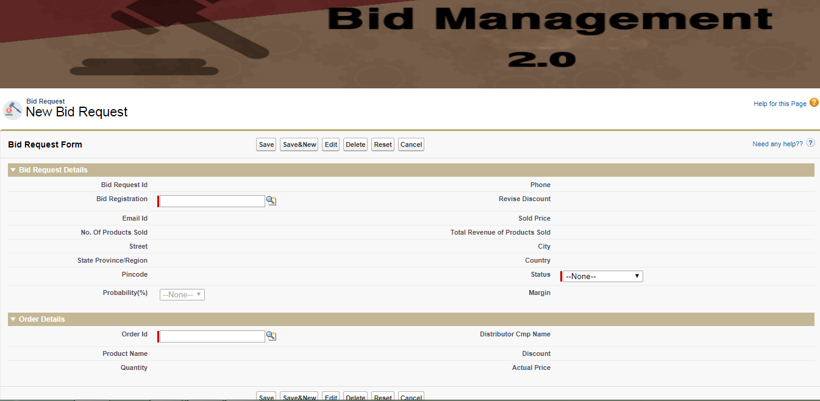

|  |  |  |  |  |
| --- | --- | --- | --- | --- |
| S.No | Field Name | Data Type | Value | Validation |
| 1 | Request Id | Auto Num | Bid_ReqID-{000001}-mmyyyy | - |
| 3 | Bid Registration | LookUp(BidRegistration__c) | REGID-{000001}-mmyyyy |  |
| 4 | Name Of the Distributor | Formula | LN- FN | From Bid Registration |
| 5 | Phone Number | Formula | 9985464537 | Valid no. & should contain 10 digits |
| 6 | Email Id | Formula | a@a.com | - |
| 7 | Status | Picklist | Submitted,Opened-Working,Approval,won-Closed | Field Dependency on Probability |
| 8 | Probabitity | Picklist | 30%,50%,80%,100% | - |
| 9 | Street | Formula | abcd | - |
| 10 | City | Formula | abcddde | - |
| 11 | State | Formula |  |  |
| 12 | Country | Formula |  |  |
| 13 | Pincode | Formula |  |  |
| 14 | Location | Formula | Latitude  Longitute |  |
| Order Details | | | | |
| 15 | Re-Bid Submission | Checkbox, required |  |  |
| 16 | Revise Discount | Currency, Required | $10 |  |
| 17 | Description | TextArea | -Some text- |  |
| 18 | Payment Mode | Picklist,required |  |  |
| 19 | Account Id | Number,required | 12345678909 |  |
| 20 | Bid Submission Date | Date,required | 4/3/2020 |  |
| Order Details | | | | |
| 21 | Order Id | Lookup(Order_List__c) | OrderID-000001-mmyyyy |  |
| 22 | Distributor cmp Name | formula |  |  |
| 23 | Product Name | formula |  |  |
| 24 | Discount | formula |  |  |
| 25 | Quantity | formula |  |  |
| 27 | Actual Price | formula |  |  |
| 30 | Ordered Closed Date | formula |  |  |
|  |  |  |  |  |

VF Page[Bid Request]:

<apex:page id="p1" standardController="Bid_Request__c" showHeader="false" sidebar="false">

<apex:image value="{!$Resource.Hm4}" height="200" width="1366"/><br/>

<apex:sectionHeader id="sh1" title="Bid Request" subtitle="New Bid Request" help="/apex/Home"/>

<apex:form id="f1">

<apex:pageBlock tabStyle="Bid_Request__c" id="pb1" title="Bid Request Form" helpTitle="Need any help??" helpUrl="https://developer.salesforce.com/docs/atlas.en-us.pages.meta/pages/pages_compref_pageBlockSection.htm">

<apex:pageBlockButtons id="pbb1" location="both">

<apex:commandButton id="cb1" value="Save" />

<apex:commandButton id="cb2" value="Save&New" />

<apex:commandButton id="cb3" value="Edit" />

<apex:commandButton id="cb4" value="Delete" />

<apex:commandButton id="cb5" value="Reset" />

<apex:commandButton id="cb6" value="Cancel" />

</apex:pageBlockButtons>

<apex:pageBlockSection id="pbs1" title="Bid Request Details">

<apex:inputField id="if1" value="{!Bid_Request__c.Name}" />

<apex:inputField id="if2" value="{!Bid_Request__c.Phone__c}" />

<apex:inputField id="if3" value="{!Bid_Request__c.Bid_Registration__c}" />

<apex:inputField id="if4" value="{!Bid_Request__c.Revise_Discount__c}" />

<apex:inputField id="if5" value="{!Bid_Request__c.Email_Id__c}" />

<apex:inputField id="if6" value="{!Bid_Request__c.Sold_Price__c}" />

<apex:inputField id="if7" value="{!Bid_Request__c.No_Of_Products_Sold__c}" />

<apex:inputField id="if8" value="{!Bid_Request__c.Total_Revenue_of_Products_Sold__c}" />

<apex:inputField id="if9" value="{!Bid_Request__c.Street__c}" />

<apex:inputField id="if10" value="{!Bid_Request__c.City__c}" />

<apex:inputField id="if11" value="{!Bid_Request__c.State_Province_Region__c}" />

<apex:inputField id="if12" value="{!Bid_Request__c.Country__c}" />

<apex:inputField id="if13" value="{!Bid_Request__c.Pincode__c}" />

<apex:inputField id="if14" value="{!Bid_Request__c.Status__c}" />

<apex:inputField id="if15" value="{!Bid_Request__c.Probability__c}" />

<apex:inputField id="if16" value="{!Bid_Request__c.Margin__c}" />

</apex:pageBlockSection>

<apex:pageBlockSection id="pbs2" title="Order Details">

<apex:inputField id="if1" value="{!Bid_Request__c.Order_Id__c}" />

<apex:inputField id="if2" value="{!Bid_Request__c.Distributor_Cmp_Name__c}" />

<apex:inputField id="if3" value="{!Bid_Request__c.Product_Name__c}" />

<apex:inputField id="if4" value="{!Bid_Request__c.Discount__c}" />

<apex:inputField id="if5" value="{!Bid_Request__c.Quantity__c}" />

<apex:inputField id="if6" value="{!Bid_Request__c.Actual_Price__c}" />

</apex:pageBlockSection>

</apex:pageBlock>

</apex:form>

</apex:page>

List View:

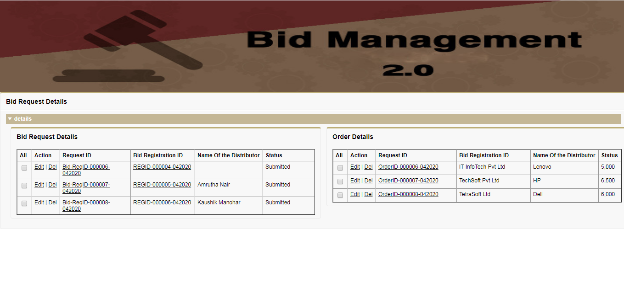On **Edit** Option Page Redirects to the following Page view: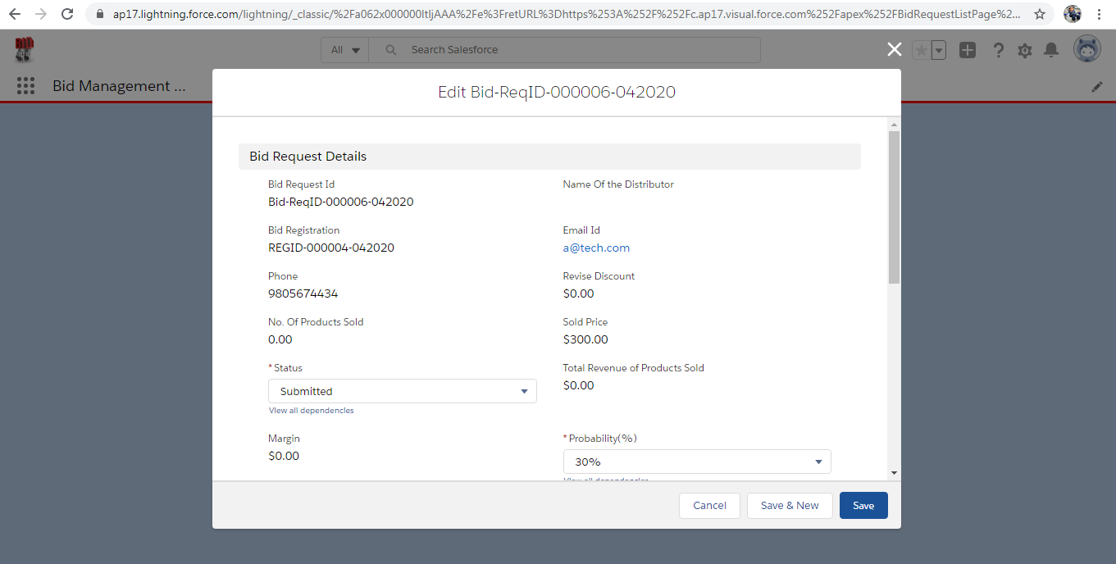

Click on Edit/Delete—Default taken as Standard Action[Edit / Delete]

VF Page[Request List View]:

<apex:page id="p1" standardController="Bid_Request__c" showHeader="false" sidebar="false" recordSetVar="items">

<apex:image value="{!$Resource.Hm4}" height="200" width="1366"/><br/>

<apex:form >

<apex:pageBlock id="pb1" title="Bid Request Details">

<apex:inlineEditSupport >

<apex:pageBlockSection id="pbs1" title="details" columns="2">

<apex:pageBlock id="pb1" title="Bid Request Details">

<apex:dataTable id="dt1" value="{!items}" var="Req" width="650" columnsWidth="15,20,200,150,50,130" border="box" cellpadding="5">

<apex:column id="c1" headerValue="All">

<apex:inputCheckbox id="ic1"/>

</apex:column>

<apex:column id="c2" headerValue="Action">

<apex:commandLink value="Edit" action="{!URLFOR($Action.Bid_Request__c.Edit,Req.Id)}"/>&nbsp;|&nbsp;

<apex:commandLink value="Del" action="{!URLFOR($Action.Bid_Request__c.Delete,Req.Id)}"/>

</apex:column>

<apex:column id="c3" headerValue="Request ID">

<apex:commandLink id="cl1" value="{!Req.Name}" action="/{!Req.Id}"/>

</apex:column>

<apex:column id="c4" headerValue="Bid Registration ID" value="{!Req.Bid_Registration__c}"/>

<apex:column id="c5" headerValue="Name Of the Distributor" value="{!Req.Name_Of_the_Distributor__c}"/>

<apex:column id="c6" headerValue="Status" value="{!Req.Status__c}"/>

</apex:dataTable>

</apex:pageBlock>

<apex:pageBlock id="pb2" title="Order Details">

<apex:dataTable id="dt2" value="{!items}" var="Req" width="630" columnsWidth="15,20,280,200,50,50" border="box" cellpadding="5">

<apex:column id="c1" headerValue="All">

<apex:inputCheckbox id="ic1"/>

</apex:column>

<apex:column id="c2" headerValue="Action">

<apex:commandLink value="Edit"/>&nbsp;|&nbsp;

<apex:commandLink value="Del"/>

</apex:column>

<apex:column id="c3" headerValue="Request ID" value="{!Req.Order_Id__c}"/>

<apex:column id="c4" headerValue="Bid Registration ID" value="{!Req.Distributor_Cmp_Name__c}"/>

<apex:column id="c5" headerValue="Name Of the Distributor" value="{!Req.Product_Name__c}"/>

<apex:column id="c6" headerValue="Status" value="{!Req.Quantity__c}"/>

</apex:dataTable>

</apex:pageBlock>

</apex:pageBlockSection>

</apex:inlineEditSupport>

</apex:pageBlock>

</apex:form>

</apex:page>

***Order Form:***

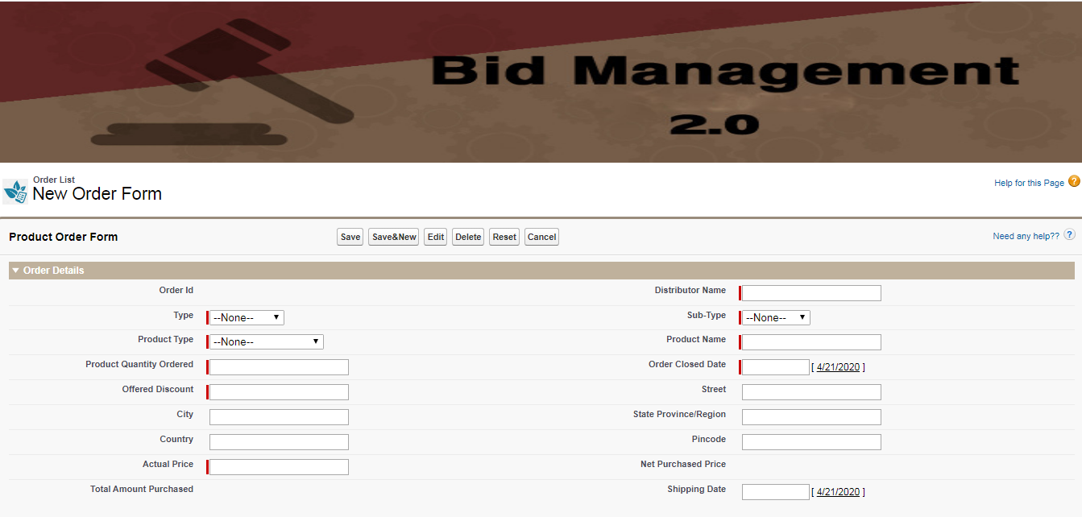

VF Page[Order Form]:

<apex:page id="p1" standardController="Order_List__c" showHeader="false" sidebar="false">

<apex:image value="{!$Resource.Hm4}" height="200" width="1366"/><br/>

<apex:sectionHeader id="sh1" title="Order List" subtitle="New Order Form" help="/apex/Home"/>

<apex:form id="f1">

<apex:pageBlock id="pb1" tabStyle="Order_List__c" title="Product Order Form" helpTitle="Need any help??" helpUrl="/apex/Home">

<apex:pageBlockButtons id="pbb1" location="both">

<apex:commandButton id="cb1" value="Save" />

<apex:commandButton id="cb2" value="Save&New" />

<apex:commandButton id="cb3" value="Edit" />

<apex:commandButton id="cb4" value="Delete" />

<apex:commandButton id="cb5" value="Reset" />

<apex:commandButton id="cb6" value="Cancel" />

</apex:pageBlockButtons>

<apex:pageBlockSection id="pbs1" title="Order Details">

<apex:inputField id="if1" value="{!Order_List__c.Name}" />

<apex:inputField id="if2" value="{!Order_List__c.Distributor_Name__c}" />

<apex:inputField id="if3" value="{!Order_List__c.Type__c}" />

<apex:inputField id="if4" value="{!Order_List__c.Sub_Type__c}" />

<apex:inputField id="if5" value="{!Order_List__c.Product_Type__c}" />

<apex:inputField id="if6" value="{!Order_List__c.Product_Name__c}" />

<apex:inputField id="if7" value="{!Order_List__c.Product_Quantity_Ordered__c}" />

<apex:inputField id="if8" value="{!Order_List__c.Order_Closed_Date__c}" />

<apex:inputField id="if9" value="{!Order_List__c.Offered_Discount__c}" />

<apex:inputField id="if10" value="{!Order_List__c.Street__c}" />

<apex:inputField id="if11" value="{!Order_List__c.City__c}" />

<apex:inputField id="if12" value="{!Order_List__c.State_Province_Region__c}" />

<apex:inputField id="if13" value="{!Order_List__c.Country__c}" />

<apex:inputField id="if14" value="{!Order_List__c.Pincode__c}" />

<apex:inputField id="if15" value="{!Order_List__c.Actual_Price__c}" />

<apex:inputField id="if16" value="{!Order_List__c.Net_Purchased_Price__c}" />

<apex:inputField id="if17" value="{!Order_List__c.Total_Amount_Purchased__c}" />

<apex:inputField id="if18" value="{!Order_List__c.Shipping_Date__c}" />

</apex:pageBlockSection>

</apex:pageBlock>

</apex:form>

</apex:page>

***Order Detailed List:***

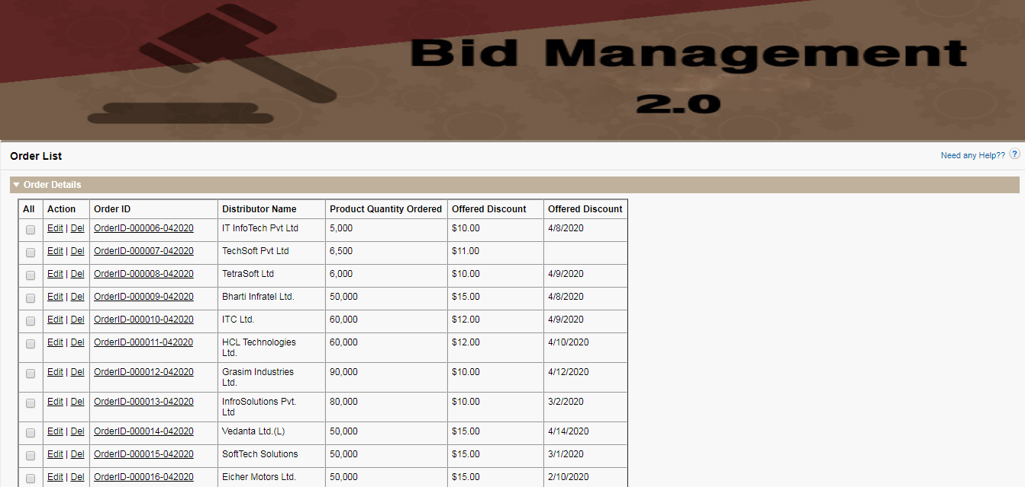

VF Page[Order List View]:

<apex:page id="p1" standardController="Order_List__c" showHeader="false" sidebar="false" recordSetVar="items">

<apex:image value="{!$Resource.Hm4}" height="200" width="1366"/><br/>

<apex:form >

<apex:pageBlock id="pb1" title="Order List" helpTitle="Need any Help??" helpUrl="/apex/BID_OrderPage">

<apex:inlineEditSupport >

<apex:pageBlockSection id="pbs1" title="Order Details" columns="2">

<apex:dataTable id="dt1" value="{!items}" var="Req" width="800" columnsWidth="15,20,200,150,50,130,100" border="box" cellpadding="5">

<apex:column id="c1" headerValue="All">

<apex:inputCheckbox id="ic1"/>

</apex:column>

<apex:column id="c2" headerValue="Action">

<apex:commandLink value="Edit" action="{!URLFOR($Action.Order_List__c.Edit,Req.Id)}"/>&nbsp;|&nbsp;

<apex:commandLink value="Del" action="{!URLFOR($Action.Order_List__c.Delete,Req.Id)}"/>

</apex:column>

<apex:column id="c3" headerValue="Order ID">

<apex:commandLink id="cl1" value="{!Req.Name}" action="/{!Req.Id}"/>

</apex:column>

<apex:column id="c4" headerValue="Distributor Name" value="{!Req.Distributor_Name__c}"/>

<apex:column id="c5" headerValue="Product Quantity Ordered" value="{!Req.Product_Quantity_Ordered__c}"/>

<apex:column id="c6" headerValue="Offered Discount" value="{!Req.Offered_Discount__c}"/>

<apex:column id="c7" headerValue="Offered Discount" value="{!Req.Order_Closed_Date__c}"/>

</apex:dataTable>

</apex:pageBlockSection>

</apex:inlineEditSupport>

</apex:pageBlock>

</apex:form>

</apex:page>

***End Customer Form:***

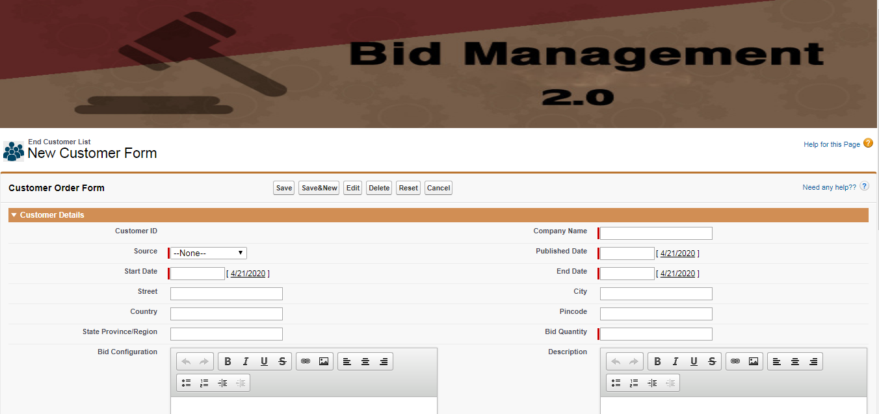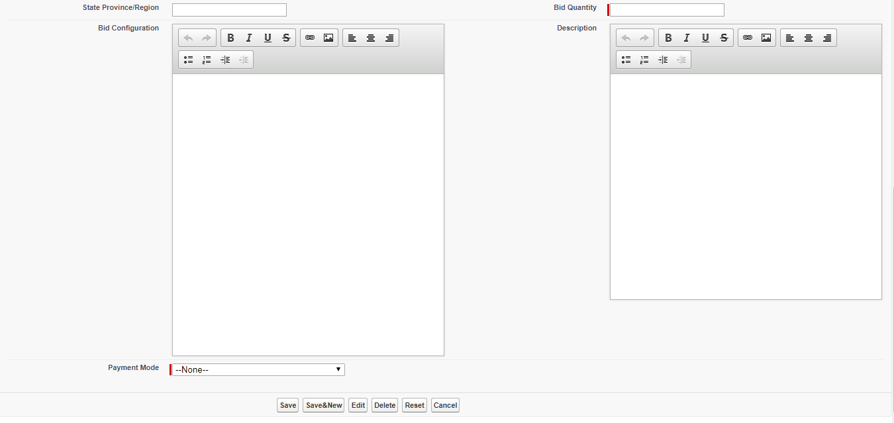

VF Page[End Customer Form]:

<apex:page id="p1" standardController="End_Customer_List__c" showHeader="false" sidebar="false" >

<apex:image value="{!$Resource.Hm4}" height="200" width="1366"/><br/>

<apex:sectionHeader id="sh1" title="End Customer List" subtitle="New Customer Form" help="/apex/Home"/>

<apex:form id="f1">

<apex:pageBlock id="pb1" tabStyle="End_Customer_List__c" title="Customer Order Form" helpTitle="Need any help??" helpUrl="/apex/Home">

<apex:pageBlockButtons id="pbb1" location="both">

<apex:commandButton id="cb1" value="Save" />

<apex:commandButton id="cb2" value="Save&New" />

<apex:commandButton id="cb3" value="Edit" />

<apex:commandButton id="cb4" value="Delete" />

<apex:commandButton id="cb5" value="Reset" />

<apex:commandButton id="cb6" value="Cancel" />

</apex:pageBlockButtons>

<apex:pageBlockSection id="pbs1" title="Customer Details">

<apex:inputField id="if1" value="{!End_Customer_List__c.Name}"/>

<apex:inputField id="if2" value="{!End_Customer_List__c.Company_Name__c}"/>

<apex:inputField id="if3" value="{!End_Customer_List__c.Source__c}"/>

<apex:inputField id="if4" value="{!End_Customer_List__c.Published_Date__c}"/>

<apex:inputField id="if5" value="{!End_Customer_List__c.Start_Date__c}"/>

<apex:inputField id="if6" value="{!End_Customer_List__c.End_Date__c}"/>

<apex:inputField id="if7" value="{!End_Customer_List__c.Street__c}"/>

<apex:inputField id="if8" value="{!End_Customer_List__c.City__c}"/>

<apex:inputField id="if9" value="{!End_Customer_List__c.Country__c}"/>

<apex:inputField id="if10" value="{!End_Customer_List__c.Pincode__c}"/>

<apex:inputField id="if11" value="{!End_Customer_List__c.State_Province_Region__c}"/>

<apex:inputField id="if12" value="{!End_Customer_List__c.Bid_Quantity__c}"/>

<apex:inputField id="if13" value="{!End_Customer_List__c.Bid_Configuration__c}"/>

<apex:inputField id="if14" value="{!End_Customer_List__c.Description__c}"/>

<apex:inputField id="if15" value="{!End_Customer_List__c.Payment_Mode__c}"/>

</apex:pageBlockSection>

</apex:pageBlock>

</apex:form>

</apex:page>

====================================== Still InProgress ==================================